**A PROJECT**

**ON**

**DIGITAL MARKETING – THE NEW FACE OF MARKETING COMMUNICATION**

**BY**

**NAME OF THE STUDENT: Abhishek Ranaut**

**TO WHOM IT MAY CONCERN**

This is to certify that Abhishek Ranaut a student of B.Tech 3rd Year, from LOVELY PROFESSIONAL UNIVERSITY has successfully completed the project on “DIGITAL MARKETING –THE NEW FACE OF MARKETING COMMUNICATION”. The assignment being submitted is genuine and original work to the best of my knowledge.

**TABLE OF CONTENT**

|  |  |  |
| --- | --- | --- |
| **SL.NO** | **TOPIC** | **PAGE NO.** |
| 1 | EXECUTIVE SUMMARY | 3 |
| 2 | INTRODUCTION | 4-5 |
| 3 | LITERATURE REVIEW | 6-9 |
| 4 | AIMS AND OBJECTIVES | 10 |
| 5 | METHODOLOGY | 11 |
| 6 | INDUSTRY ANALYSIS | 12-17 |
| 7 | INDIA AND INTERNET POPULATION | 18-23 |
| 8 | DIGITAL MARKETING | 24-35 |
| 9 | RESULTS AND DISCUSSIONS | 36-41 |
| 6 | FINDINGS | 42 |
| 7 | CONCLUSION | 43 |
| 8 | REFERENCES | 44-46 |
|  |  |  |

**EXECUTIVE SUMMARY**

I am Abhishek Ranaut. This report explains the importance of digital media marketing in present era and this report will help the reader to get an idea about the Industry, Indian population and digital media, concepts of digital marketing, Duties and responsibility of client servicing executives in an agency, Steps involved in client servicing and Consumer buying behavior in the digital era. After reading the whole report the reader will be able understand the reason behind growing digital media marketing.

Title of the Report is **“Digital Marketing – The New Face Of Marketing Communication”** and Objectives of the project is to understand the change in consumer buying behavior in digital era.

Methodologies used for achieving the objective are descriptive study and a research. For achieving the objective, I have done one research using an online questionnaire. The title for the research is ***“Understand the consumer buying behaviour of Indian in digital era”.***

Main findings of the research are given here. Indian customers are highly information seekers. They collect more information about a product before buying it. Internet penetration in India is key player for this phenomenon. Most of Indians are getting stimulus through advertisements, but they are not reaching to end phase of customers purchase journey, mainly in high involvement purchases. Brands are getting more touch point to reach their target group in this digital era. More details about findings are given this report.

The successful completion of this project indicates that the future of marketing is in the hands of digital. I conclude my research by quoting again that ***“Brands can’t sustain without digital presence”***

**INTRODUCTION**

Advertising in business is a form of marketing communication used to encourage, persuade, or manipulate an audience to take or continue to take some action. Most commonly, the desired result is to drive consumer behaviour with respect to a commercial offering. Advertising is defined by Richard F. Taflinger as “Advertising is the non-personal communication of information usually paid for and usually persuasive in nature about products, services or ideas by identified sponsors through the various media."

Advertising is normally done by a third party known as advertising agency. An advertising agency is a service based business dedicated to creating, planning, and handling advertising for its clients. An ad agency is independent from the client and provides an outside point of view to the effort of selling the client's products or services. An agency can also handle overall marketing and branding strategies and sales promotions for its clients. Types of ad agencies are

* Full service agencies
* Creative agencies
* Specialized agencies
* In-house agencies
* Digital agencies or new media agencies

This report is completely discussing about digital or new media agencies. There was a time when Television was the most popular medium for Marketer to promote, spread awareness and generate leads for their products but now the trend has changed and Digital media has taken its place. Main reason for this change was

* Traditional methods are expensive. Compared to digital marketing channels, you could end up spending thousands of dollars more.
* Traditional marketing channels fail to provide instant feedback and reports about who saw or heard an ad, and took action. This data is collected long after the initial ad impression is made (and still then, the statistics are far from exact numbers).

Digital marketing, on the other hand, refers to marketing methods that allow organizations to see how a campaign is performing in real-time, such as what is being viewed, how often, how long, as well as other statistics such as sales conversions.

## Digital Media Marketing or Digital Marketing

The term 'digital marketing' was first used in the 1990s. In the 2000s and the 2010s, digital marketing became more sophisticated as an effective way to create a relationship with the consumer that has depth and relevance.

**Digital marketing was defined in Wikipedia as** “marketing that makes use of electronic devices (computers) such as personal computers, smart phones, cell phones, tablets and game consoles to engage with customers. Digital marketing applies technologies or platforms such as websites, e-mail, apps (classic and mobile) and social networks”.

Peoples often referred digital marketing as 'online marketing' or 'internet marketing' but it’s wrong. Digital marketing revolves around the Internet, which explains why people tend to believe that digital marketing and Internet marketing are synonymous. Nonetheless, they are different. Internet marketing falls under the category of digital marketing. Internet marketing encompasses digital marketing services such as search engine optimization, display advertising, and email marketing.

**LITERATURE REVIEW**

The purpose of doing research in the area of digital marketing is because it seem huge, intimidating and foreign. Businesses are looking for clearer picture to start but do not know where and how to start doing digital marketing. In today’s time, social media channels such as Face book, Twitter, Google and other social media firms have successfully transformed the attitudes and perceptions of consumers and in the end helped revolutionized many businesses. This was done through measurable vast network of customers with trustworthy data with real-time feedback of customer experiences.

It is much more convenient for businesses to conduct surveys online with a purpose to get relevant information from targeted groups and analyzing the results based on their responses. Potential customers can look for reviews and recommendations to make informed decisions about buying a product or using the service. On the other hand, businesses can use the exercise to take action on relevant feedback from customers in meeting their needs more accurately.

**Digital marketing is the use of technologies to help marketing activities in order to improve customer knowledge by matching their needs (Chaffey, 2013).**

Marketing has been around for a long time. Business owners felt the need to spread the word about their products or services through newspapers and word of mouth. Digital marketing on the other end is becoming popular because it utilizes mass media devices like television, radio and the Internet. The most common digital marketing tool used today is Search Engine Optimization (SEO). Its role is to maximize the way search engines like Google find your website.

Digital marketing concept originated from the Internet and search engines ranking of websites. The first search engine was started in 1991 with a network protocol called Gopher for query and search. After the launch of Yahoo in 1994 companies started to maximize their ranking on the website (Smyth 2007).

When the Internet bubble burst in 2001, market was dominated by Google and Yahoo for search optimization. Internet search traffic grew in 2006; the rise of search engine optimization grew for major companies like Google (Smyth 2007). In 2007, the usage of mobile devices increased the Internet usage on the move drastically and people all over the world started connecting with each other more conveniently through social media.

In the developed world, companies have realized the importance of digital marketing. In order for businesses to be successful they will have to merge online with traditional methods for meeting the needs of customers more precisely (Parsons, Zeisser, Waitman 1996).

Introduction of new technologies has creating new business opportunities for marketers to manage their websites and achieve their business objectives (Kiani, 1998).

With the availability of so many choices for customers, it is very difficult for marketers to create brands and increase traffic for their products and services. Online advertising is a powerful marketing vehicle for building brands and increasing traffic for companies to achieve success (Song, 2001). Expectations in terms of producing results and measuring success for advertisement money spent, digital marketing is more cost-efficient for measuring ROI on advertisement (Pepelnjak, 2008).

Today, monotonous advertising and marketing techniques have given way to digital marketing. In addition, it is so powerful that it can help revive the economy and can create tremendous opportunities for governments to function in a more efficient manner (Munshi, 2012). Firms in Singapore have tested the success of digital marketing tools as being effective and useful for achieving results. (Teo, 2005). More importantly, growth in digital marketing has been due to the rapid advances in technologies and changing market dynamics (Mort, Sullivan, Drennan, Judy, 2002). In order for digital marketing to deliver result for businesses, digital content such as accessibility, navigation and speed are defined as the key characteristics for marketing (Kanttila, 2004). Other tried and tested tool for achieving success through digital marketing is the use of word-of-mouth WOM on social media and for making the site popular (Trusov, 2009). In addition, WOM is linked with creating new members and increasing traffic on the website which in return increases the visibility in terms of marketing.

Social media with an extra ordinary example Facebook has opened the door for businesses to communicate with millions of people about products and services and has opened new marketing opportunities in the market. This is possible only if the managers are fully aware of using the communication strategies to engage the customers and enhancing their experience (Mangold, 2009). Marketing professional must truly understand online social marketing campaigns and programs and understand how to do it effectively with performance measurement indicators. As the market dynamics all over the world are changing in relation to the young audience accessibility to social media and usage. It is important that strategic integration approaches are adopted in organization’s marketing communication plan (Rohm & Hanna, 2011).

Blogs as a tool for digital marketing have successfully created an impact for increasing sales revenue, especially for products where customers can read reviews and write comments about personal experiences. For businesses, online reviews have worked really well as part of their overall strategic marketing strategy (Zhang, 2013). Online services tools are more influencing than traditional methods of communication ( Helm, Möller, Mauroner, Conrad, 2013). As part of study, it is proven that users experience increase in self-esteem and enjoyment when they adapt to social media which itself is a motivating sign for businesses and marketing professional (Arnott, 2013). Web experiences affect the mental process of consumers and enhance their buying decision online (Cetină, Cristiana, Rădulescu, 2012). This study is very valuable for marketing professional as it highlights the importance of digital marketing.

The Internet is the most powerful tool for businesses (Yannopoulos, 2011). Marketing managers who fail to utilize the importance of the Internet in their business marketing strategy will be at disadvantage because the Internet is changing the brand, pricing, distribution and promotion strategy.

Pakistan has seen tremendous growth in media with 20 million people have access to the Internet but still marketers insist on doing things the traditional way (Mohsin 2010). Management and structure in Pakistan are still based on ancient paradigm where customers are moving ahead with their demands and expectations. This gap is widening day by day with limited skills and mindset available in Pakistan to solve the problem for the demanding customers. Companies in Pakistan including the MNC’s are going the traditional way and keeping the digital aspect just to show off in tune with the modern trends.

### 

### AIMS AND OBJECTIVES

#### PRIMARY OBJECTIVE

* The main objective of the study is to understand the consumer buying journey in Digital era.

#### SECONDARY OBJECTIVES

* To know affinity in customers for collecting information before purchase.
* To determine out the media, which is most important in creating stimulus in Indians?
* To understand the media consumption of Indians.
* To figure out how Indian will purchase a product.
* To understand post purchase behaviour of Indian

## 

## METHODOLOGY

The **descriptive research design** is used for analyzing and studying the process of Business Development. It is very simple & more specific than explanatory study.

**Data Sources:**

**Primary Data**: -

It is a firsthand data which is collected by you only. The different way of collecting primary data is personal interview, questionnaire, survey etc. As my project is descriptive study there is no primary data collected as such.

**Secondary Data:-**

Secondary data is collected from already existing sources in various organization broachers & records. Secondary data for the study were collected from the magazines, websites & other previous studies.

To meet the objectives, the study used qualitative research. The descriptive study was done through review of existing literature that helped in validation and extraction of the important variables and factors. Data was collected from secondary sources. Secondary sources were magazines, websites, books, office executives, and company data.

I have also used an online questionnaire to understand the consumer buying behaviour of Indians in digital era

**INDUSTRY ANALYSIS**

The Indian Media and Entertainment (M&E) Industry, one of the most vibrant and exciting industries in the world, has had a tremendous impact on the lives and the Indian economy. As the M&E industry widens its reach, it plays a critical role in creating awareness on issues affecting, channelling the energy of and building aspirations among India’s millions. As it entertains and informs the country, the M&E industry has been a catalyst for the growth of large parts of the Indian economy. M&E industry consist of TV, Print, Films, Radio, Music, OOH, Animation and VFX, Gaming and Digital Advertising.

The **FICCI-KPMG 2014** Report 'The Stage Is Set' showing the Indian media and entertainment (M&E) industry has grown by 11.8 per cent in 2013 while comparing with 2012 and touched Rs 918 billion. It is expected to touch Rs 1785.8 billion by 2018, with a CAGR of 14.2 per cent.

By the end of 2014, the industry is expected to stand at Rs 1039 billion. Additionally, digital advertising has shown promising growth in 2013 while comparing with 2012, which is about 38.7 per cent, followed by gaming which grew by 25.5 per cent. As for the 2018 prediction: Digital advertising is expected to lead the CAGR with 27.7 per cent, followed by radio with 18.1 per cent. Gaming and television are expected to register a CAGR of 16.2 per cent each, followed by growth rates of animation and VFX (15.9 per cent), music (13.2 per cent), films (11.9 per cent) and OOH with 9.2 per cent expected CAGR.

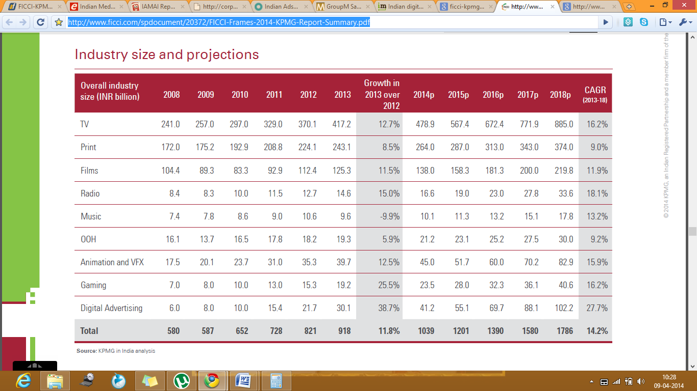

According to the annual advertising expenditure report from **GroupM**, The digital media advertising revenues for the year 2013 is estimated at Rs 2,520.1 crore (around $405 million) , up 30% from Rs 1,938.6 crore in 2012,. Digital contributed to 6.5% of the total media advertising expenditure in 2013, up from 5.5% share in 2012.

The agency estimates that the digital media advertising revenues to reach Rs 3,402.2 crore ($546 million) in 2014, registering a 35% growth year on year. This will represent around 7.9% of the total media advertising expenditure in 2014, which is estimated at Rs 43,065.4 crore. The company notes this will be driven by election spending by the government and political parties across all media.  GroupM made the prediction in the latest edition of its annual report This Year, Next Year. Digital media were projected to increase 35%, with TV slowing to 12% from last year’s 14.6% and print picking up to 8.5% from 4.6% in 2013.

Digital ad spends accounted for 8.3 percent of the total ad spends of Inr362.5 billion in 2013. Digital media advertising in India is grown by 38.7 per cent in 2013, faster than any other ad category. [6] With the dramatic growth in mobile usage, content providers and advertisers are seeking opportunities to get their message across on this preferred medium of the masses.

It is estimated that the total internet user base will reach 494 Million by the end of 2018 as against 938 million TV viewers in the same year. This means that the internet user population will be approximately 53 per cent of the total number of TV viewer in the country in 2018 compared to 27 per cent in 2013. This shift towards the digital media is important for digital media strategists to consider, in order balancing their marketing budgets between online media and traditional TV strategy.

IAMAI & IMRB report of March 2013 showing trends in breakup of Digital ad market among various ad types like search ads, display ads, mobile ads, social media ads, email ads and video ads. By seeing this breakup we can understand marketer are giving importance to all venues to place ads.

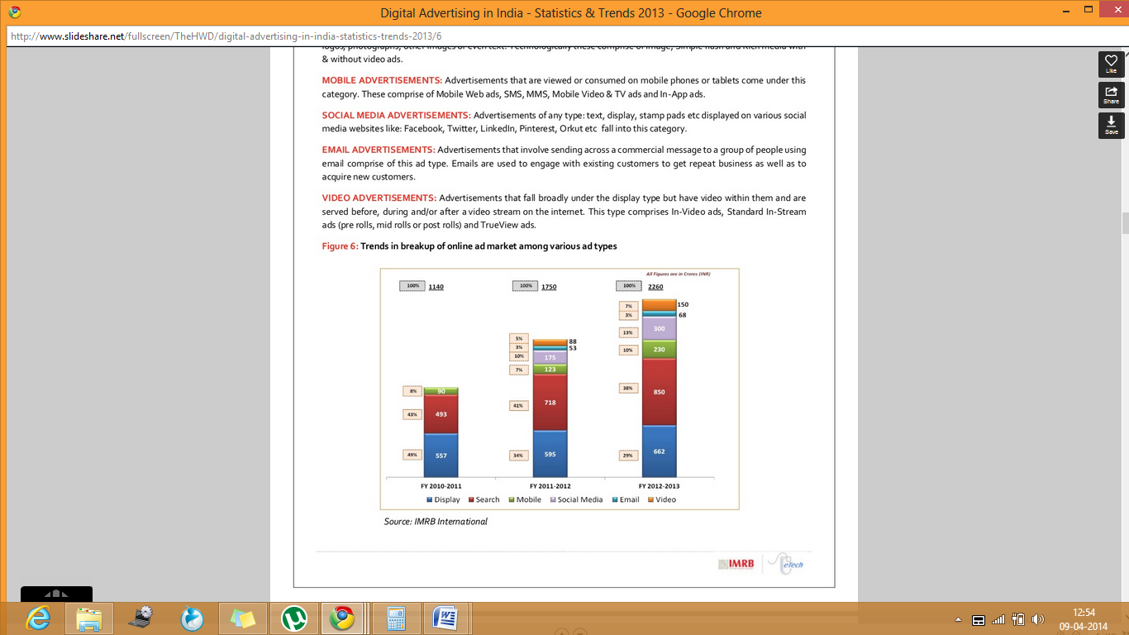

Some of the key players in the Digital advertising are Ogilvy & Mather, Webchutney, IBS, Isobar, Maxus, 22 Feet, Grey Digital, Mind Share, Interactive Avenues, Omnicom Media Group, Digital Law & Kenneth, Pinstrom.

## 2.1) Business Model of Industry

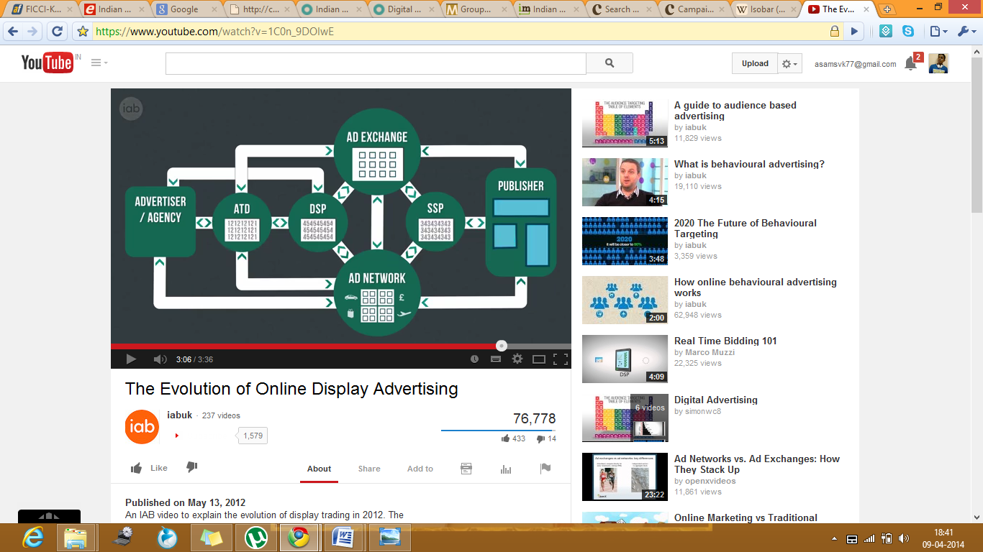

**ATD- Agency Trading Desk DSP- Demand Side Platform SSP- Selling Side Platform**

**About Process**

Clients would give authority to agencies, to wear the shoes of clients. Agency will create ads, which may be banner ads or videos. After the creation and getting approval from clients, agency while find out the portals or websites where the T.G is present. Later give the order to DSP or ATD, this order contains details regarding where to place ads or which portal is requiring to placing the ad. This DSP/ ATD will bid in ad exchange for that portal. Otherwise agency can directly approach to ad networks and give orders. These ad networks buy the inventories from publisher and give to agency. From publisher view he can sell inventories through Ad networks or through SSP. If publisher give to SSP, they will place those space in ad exchange for bidding. Through ad exchange DSP/ATD will buy those inventories. Bidding will not only for space but also for T.G which required for clients.

**Ad exchanges** are technology platforms that facilitate the bids for buying and selling of online media advertising inventory from multiple ad networks. The approach is technology-driven as opposed to the historical approach of negotiating price on media inventory.

A **demand-side platform (DSP)** is a system that allows buyers of digital advertising inventory to manage multiple ad exchange and data exchange accounts through one interface. Real-time bidding for displaying online ads takes place within the ad exchanges, and by utilizing a DSP, marketers can manage their bids for the banners and the pricing for the data that they are layering on to target their audiences. A **supply-side platform or sell-side platform (SSP)** is a technology platform, web publishers of the world use a supply-side platform to automate and optimize the selling of their online media space.

## 2.2) Porter’s Five Model Analysis of Digital Advertising Industry

Porter’s model will help analysis the industry and understand where the power lies in the business. Here I am using porter’s model to understand digital advertising industry in India. Generally, in the Indian advertising industry, contracts are long termed, and customers are likely to keep going back to the same advertiser so long as results were obtained the first time.

1. **Threats of New Entry**

* Full service agencies have high demand in Market.
* Lack of getting efficient work force is a threat in digital advertising.
* Cost of setting up a digital agency is low. But agencies need to invest a huge amount in backend function like technology.
* Getting clients in the initial stage is a bit difficult, because clients will usually look the past experience of agency.
* Government regulations in the digital advertising are low. While comparing with M&E industry.

1. **Bargaining power of suppliers**

* Lot of suppliers are there, but some suppliers who have high reach and affinity will charge high price for placing ads in their portals.
* Real time bidding will lead to increase the demand of some portals.
* Bargaining power of suppliers, who provide data and information are very high.
* Seasonal campaigns put pressure on supply side to charge high.
* Employee or work force with proper knowledge is limited.

1. **Bargaining power of buyers**

* Buyer are the clients of agencies, basically buyers are high idea seekers.
* Clients will choose agencies which have good experience in industry.
* Clients like long term relationships with agencies, so they also try to adjust with agencies.
* Clients can ask agencies to change pattern of campaigns at any time.
* Clients like MNC’s have high power over agencies, but SME’s will satisfy with performance of agencies.
* Backward integration by buyers is not possible.

1. **Threats of substitutes**

* No. of substitutes is high, substitutes include Print media, TV, OOH and Radio.
* Substitutes are too popular among buyers. They had high demand in past years.
* Main competitor for Digital advertising is TVC, but trends are now changing FICCI-KPMG report of 2014 showing growth of digital is very high while comparing with others media.
* But media consumption through radio is increasing now.

1. **Rivalry by existing competitors**

* At present competitors are low, but it can be increase in future. Because lot new players are coming to the industry.
* Existing competitors have high profile clients and clients loyal toward them.
* Most of the traditional agencies are now concentrating in digital also.
* Existing firms in the Industry are creating variety and unique campaign for clients.
* Most of the firms have efficient backend support in technology.
* Existing firms have the expertise manpower and firms giving good remunerations to employees. So employees are loyal towards employers.
* Some firms are popular due to execution of innovative campaigns.
* Few of the brands have in-house agencies, it will reduce business but not in a high level.

**Conclusion of Porter’s Five Force Analysis**

* Low threats for new entry.
* High bargaining power of suppliers.
* Bargaining power of buyer is medium, but in coming year there is chance for increase. Due to lot of players are coming to industry.
* Threats of the substitutes are high, but it will change in coming years.
* Rivalry by existing competitors is high, but possible to break it by doing some unique campaign for client.
* Indian market is a potential market for digital advertising due to high internet and mobile penetration.

**INDIA AND INTERNET POPULATION**

India, with 1,270,272,105 (1.27 billion) people is the second most populous country in the world, while China is on the top with over 1,360,044,605 (1.36 billion) people. [10] The figures show that India represents almost 17.31% of the world's population, which means one out of six people on this planet live in India. Although, the crown of the world's most populous country is on China's head for decades, India is all set to take the numerous positions by 2030. With the population growth rate at 1.58%, India is predicted to have more than 1.53 billion people by the end of 2030.

India is currently having online population of 213M, among them 60% are males and 40% are females. In have 110 M mobile internet users, among them 80% are males and 20% are females. 176M of the total internet population are part of Social Medias.

India has bypassed Japan to become the world’s third largest Internet user after China and the United States, and its users are significantly younger than those of other emerging economies, global digital measurement and analytics firm comScore has said in a report. Riding on a 31% year-on-year increase, India’s online population grew to 73.9 million. With an extended online universe in excess of 145 million the market is at a tipping point for online businesses. The numbers are lower than other recent estimates, possibly reflecting comScore’s methodology that only factors in PC and laptop-based Internet usage.

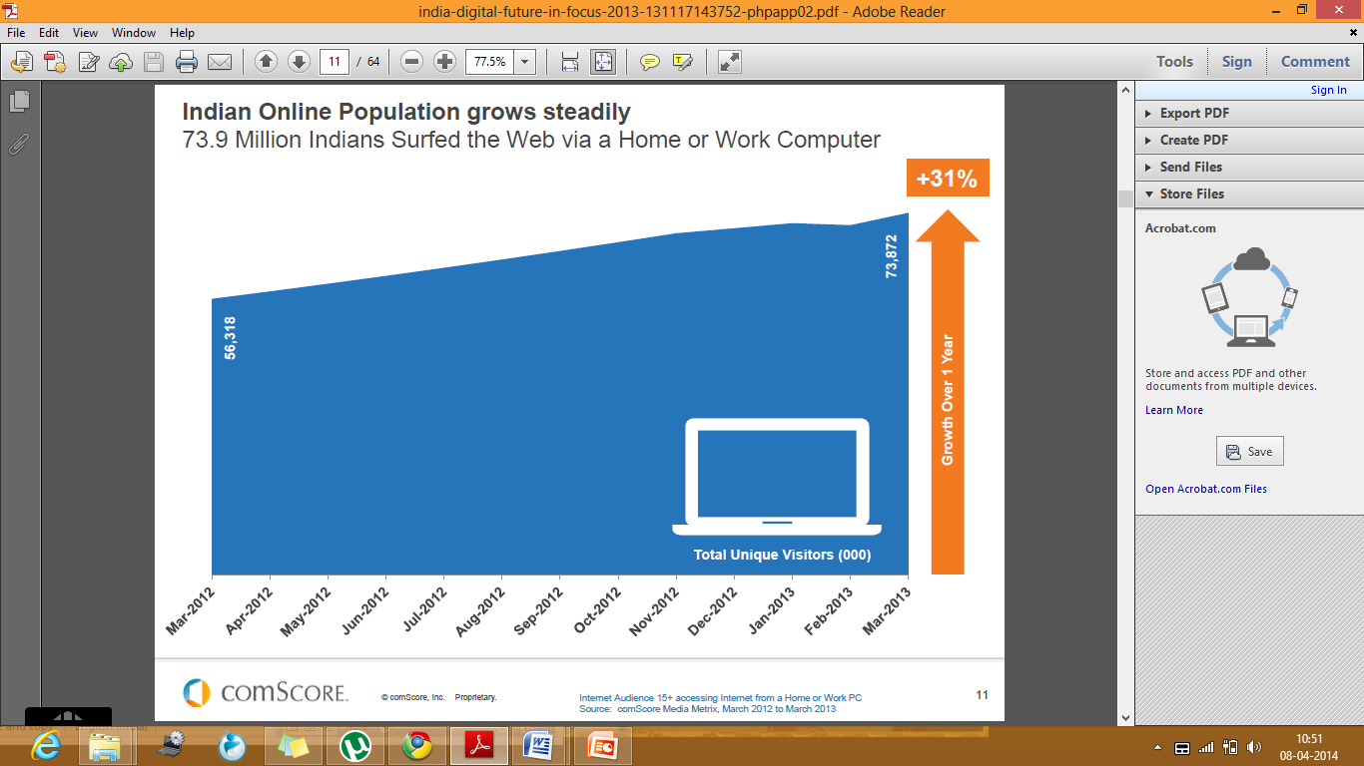

## 4.1) Gender Wise

India currently have online population of 213M, among them 60% are males and 40% are females. In have 110 M mobile internet users, among them 80% are males and 20% are females. 176M of the total internet population are part of Social Medias.

According to the Internet And Mobile Association of India (IAMAI), the Internet user base in the country stood at 190 million at the end of June, 2013. For the whole year 2013, the internet user base grew 42% to 213 million, from 150 million in 2012. With more and more people accessing the web through mobile phones, the internet user base in the country is projected to touch 243 million by June 2014, a year-on-year growth of 28%.

**Younger males and women aged 35-44 emerge as power users**

India males aged between “15-24” are major users among Males and in females 35-44 are major users of internet. Age wise distributions are given below.

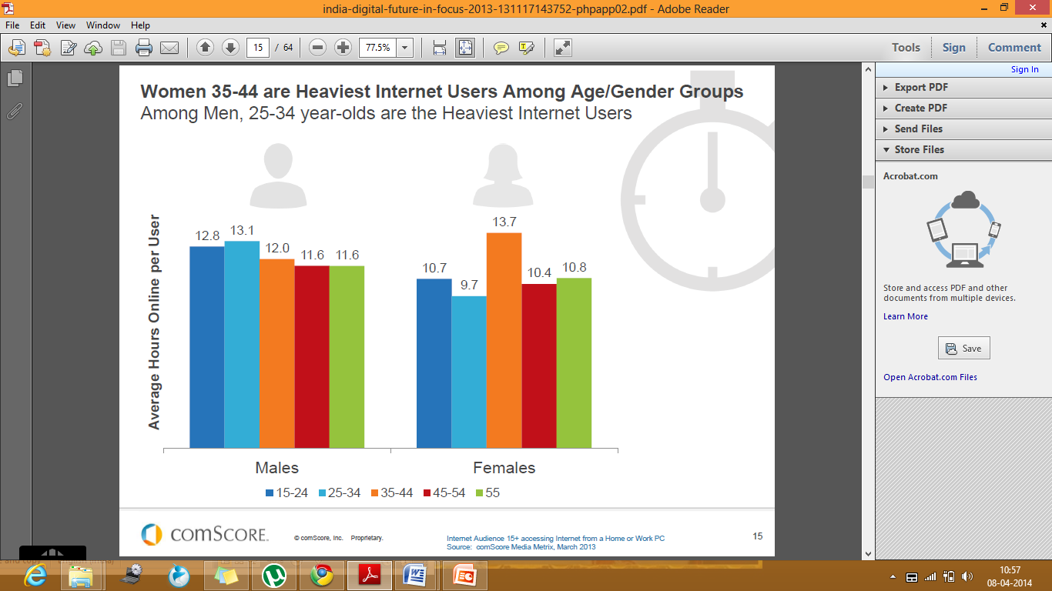

## 4.2) Online Behaviour of Indian Internet Users

Trends in online behaviour are changed a lot, social networking is leading now. Early people will use internet to access email and for searching information. But now people like to be social, they are interested in sharing their life with others. 25% of the population are doing social networking in India followed by 23% in services. Services include emailing and instant messaging.

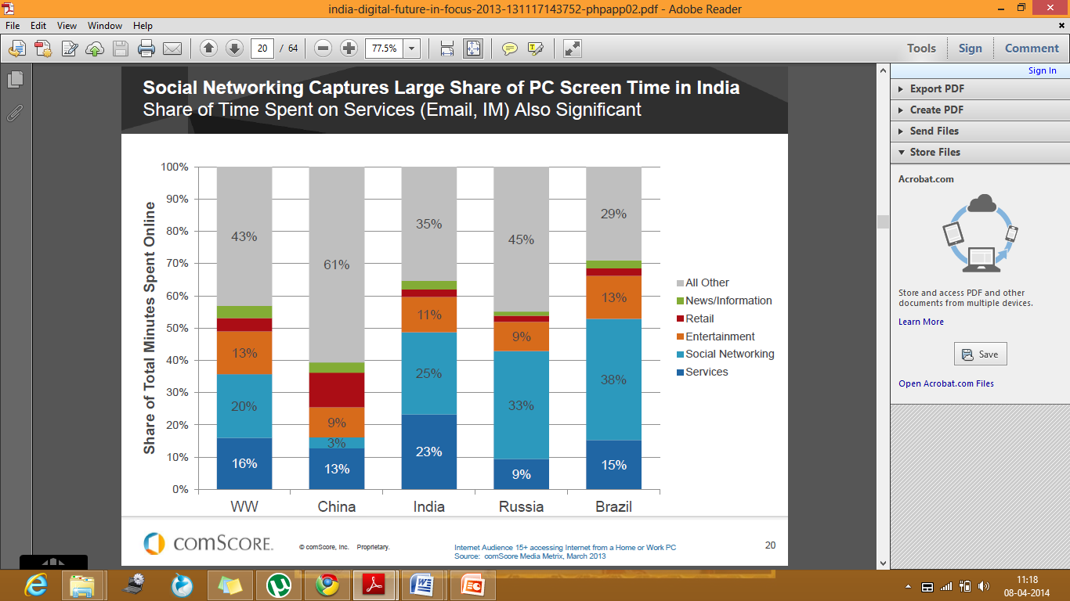

## 4.3) Mobile Internet Users

Internet penetration in India is driven largely by mobile phones, with some of the cheapest and most basic hand-sets today offering access to the internet. According to IMAI, India has 110 million mobile internet users of which 25 million are in rural India. The growth of internet penetration in rural India is driven largely by the mobile phone; 70% of rural India's active internet population access the web via mobile phones. This may have to do with the difficulty in accessing PCs. Forty-two percent of rural India's internet users prefer using the internet in local languages. The high prevalence of content in English is a hurdle for much of rural India.

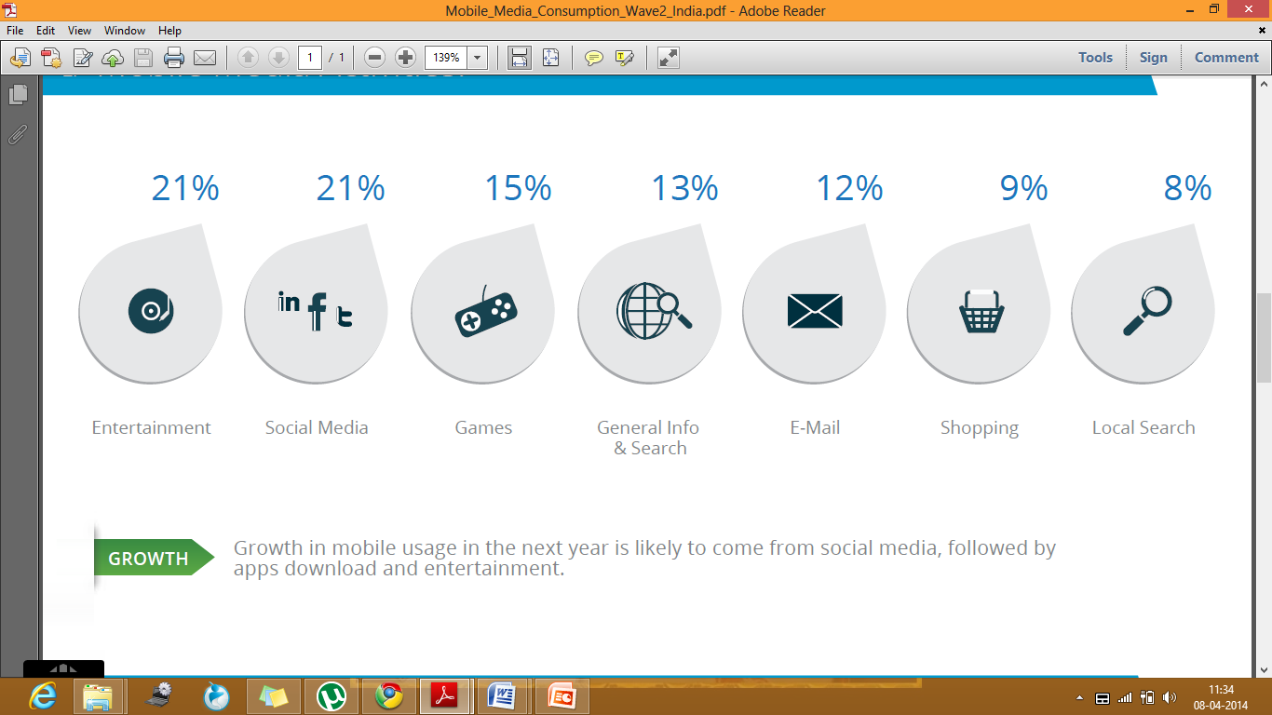

Research report of InMobi showing the behaviour mobile user in internet, 21% of their total consumption is for Entertainment and Social Media, which followed by Games, General Information Search and Email.

## 4.4) Social Networking

Social Networks capture the largest percentage of consumers’ time in the region. comScore data’s showing 86% of the Indian web user visit a social networking site. Facebook continues to be the number one social network with a 28% increase in traffic and a reach of 86%. Average time spend by a Indian user on facebook is 217 minutes. LinkedIn emerges as number two, while Pinterest and Tumblr are the fastest growing networks but growth of twitter is declined by 15% in 2013 while comparing with 2012.

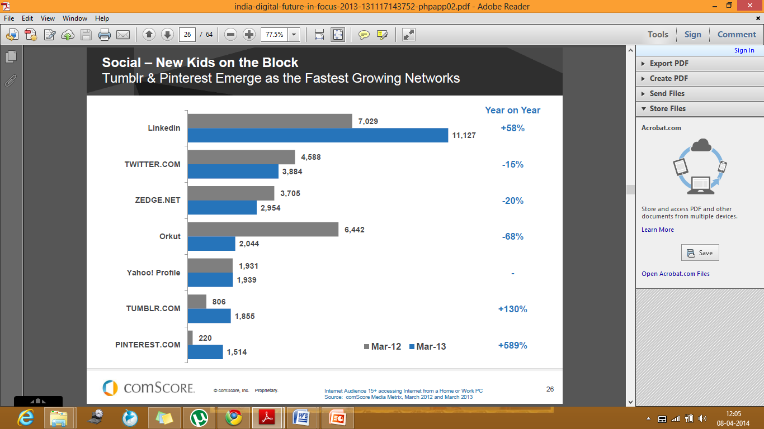

**Number of Indian user on Social Networking Platform**

Facebook- 90 Million Twitter – 30 Million LinkedIn- 18Million

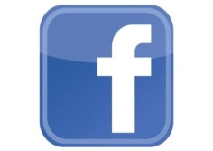  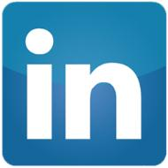

Pinterest – 15 Million Instagram- 2 Million

 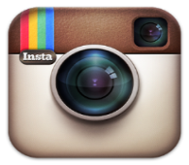 *(Source: exchange4media report, 2014)*

## 4.5) Entertainment and Online Video

According to comScore data, the online video audience in India grew an astounding 27 percent in the past years; YouTube continues to be the top video property with more than 55% share. International publishers including Facebook, Yahoo and Dailymotion get a majority of the 54 million who watched videos. YouTube is the most popular with 32,519 visitor.

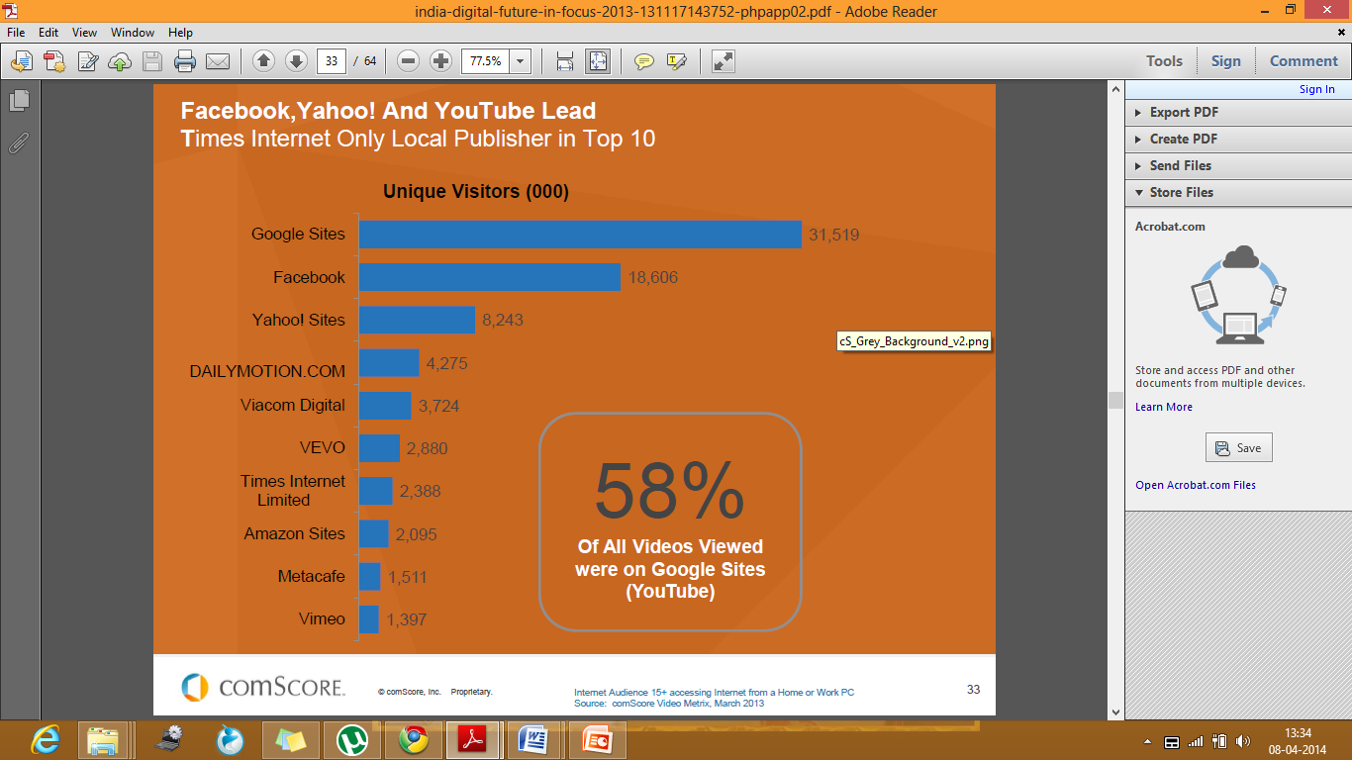

Social Video report saying 46% of internet users watch brand related video every week. 54% watching videos that are informative or entertaining often leads to a number of other positive activities such as visiting the brand website. Peoples are now likely to regularly watch videos using their smart phones. Almost six in ten internet users have gone to purchase an item after seeing it in an online video.

## 4.6) Media Consumption of Indian’s

On an average Indian consumers are spending 6.10 hours in media per day. In traditional media Indian audience spend only 195 min or 3.15 hours. If we see the breakup it will be 86min in television, 37 min in newspaper and 30 min in radio. Remaining 4.55 hours or 214 min in new media or digital media. Break up of new media will be like 102 min in mobile, 79min in online and 33 min in tablets.

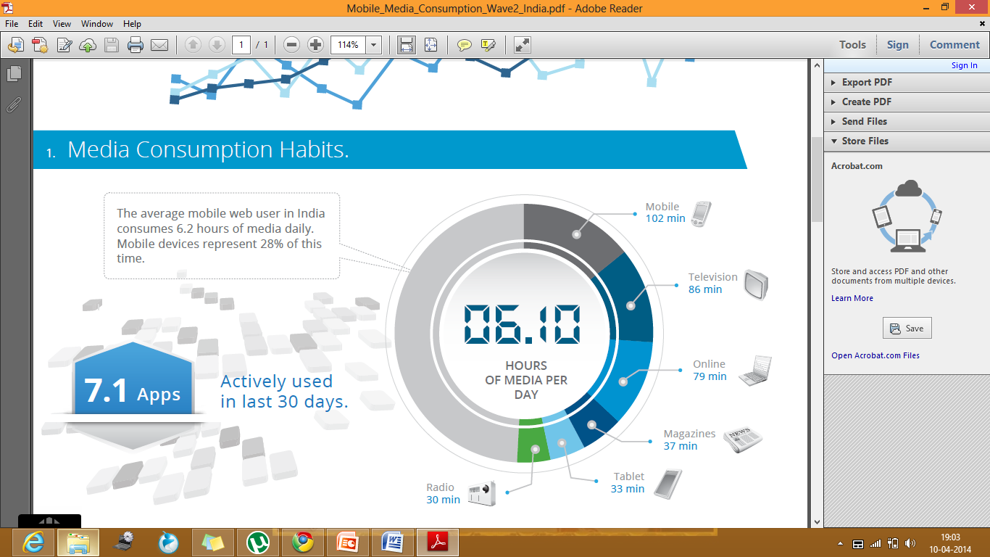

From a marketers view digital platform is very important because customers have more presence in digital media. Customers are spending more time on digital, so it is easy to catch customers in digital platform, more than that spending digital is much cost effective while comparing with traditional.

# 

# DIGITAL MARKETING

Digital marketing is the promotion of your business, organisation or brand using channels such as the Internet, mobile devices, television and radio in addition to using creative online advertising, video, podcasts and other such methods to communicate your message.[17] Internet marketing in particular plays a huge part in any digital marketing strategy and is becoming the core of many organisations overall marketing strategies, particularly with regard to social media and viral marketing.

Digital marketing ecosystem is not only concerned with internet marketing and social media marketing, in introduction we discussed that peoples have a belief that internet or social media marketing are same but not same, be clear from beginning itself. Digital marketing ecosystem consists of internet marketing and social media marketing. They are just a channels for communication, digital ecosystem consist of integrating channels and integrating services.

## 5.1) Digital Ecosystem

### 5.1.1) Search Engine

Search engine optimisation (SEO) is the art of getting a website to work better with search engines (like Google, Bing & Yahoo), and to look for achievable, profitable, ranking opportunities through keyword research. It is a quest for increased visibility in search engines via relevant copy, quality links, domain trust, social popularity and search engine connectivity.

Search engine marketing (SEM) is a broader term than SEO, and is used to encompass different options available to use a search engine’s technology, including paid ads. SEM is often used to describe acts associated with researching, submitting and positioning a website within search engines.  It includes things such as search engine optimization, paid listings and other search-engine related services and functions that will increase exposure and traffic to your Web site.

### 5.1.2) Displays

Display advertising is a type of advertising that typically contains text (i.e., copy), logos, photographs or other images, location maps, and similar items. In periodicals, display advertising can appear on the same page as, or on the page adjacent to, general editorial content. Normal banners, Rich media banner, Interstitials and pops are example of displays.

### 5.1.3) Mobile Marketing

Mobile marketing is used in reference to any marketing efforts on or with a mobile device. It involves planning, creating, and implementing a mix of initiatives to bring together sellers and buyers via mobile devices. Mobile ads, Mobile websites, Apps and Games are some of examples for mobile marketing.

### 5.1.4) Social Media Marketing

Social Media refers to any software tool that enables and encourages engagement in conversation or sharing. Popular forms of social media include Facebook, Twitter, LinkedIn, YouTube, Pinterest, Google + and blogs. Now all days social media become platform for marketer to make conversation with customers. Brands are now engaging customers through social media.

### 5.1.5) eMail Marketing

eMail Marketing is a type of direct marketing that involves sending personalized, targeted messages to a specific audience. eMail Marketing is easy to use, low cost, and effective. Most of the B2B business in present era in following email marketing, but in B2C also email marketing is productive.

### 5.1.6) Video

Marketers are now use video to make customers aware of brands and to sharing the experience of other customers. YouTube ads are too popular in video ads. In social media platforms also brands are sharing video.

### 5.1.7) Analysis

Analytics is the practice of evaluating data, and the process by which a company arrives at a most advantageous decision. Here marketer analysis the integrate channel to understand the effectiveness of communication. Analysis may be based on numbers of visitor or like in social media pages..Etc.

### 5.1.8) Content Management

After analysis the integrate channels marketer can able to understand the problems with current contents. Later he can manage the content to increase the engagement rate, content may be text in banners, images or websites.

### 5.1.9) Advanced Targeting

Advanced targeting are techniques involving the sending of targeted messages to a specific audience. It is used to increase the effectiveness of a marketing campaign. Behavioural targeting is also a part of advanced targeting, here marketer can target the customer based on their past behaviour in online. Marketer can put ads in other webpage where customer is going.

### 5.1.10) Creative

Creative is the artistic component of an ad or website. It usually includes an image and copy present in ads or website. Marketer can make those contents attractive to customers. Marketer will sometimes change the entire design of websites, apps..Etc.

### 5.1.11) Research and Planning

Marketer will do some research to understand the behaviour, taste and preference to customers in digital platform. This research may be doing by using paid-tools like ComScore...Etc. Through this research marketer can understanding where T.G is present or what T.G would to do in online. After research marketer will plan new campaigns based on those research reports. These campaigns are more effective to reach the T.G properly.

### 5.1.12) Digital Strategy

Digital strategy is the process of specifying an organization's vision, goals, opportunities and initiatives in order to maximize the business benefits through digital media. Strategy will be different for each brand, it will base on the brand objective and target groups interest. It is actual a plan formulated by the marketer to explore the opportunities. Strategy may be short term or long term, but it need to be fit with market situations.

## 5.2) Types of Digital Marketing

In normal outbound marketing, we will use pull and push marketing strategy. Like that in digital marketing also pull and push are types.

In **push digital marketing** the marketer sends a message without the recipient actively seeking the content, such as display advertising on websites and news blogs. Email, text messaging and web feeds with customized contents can also be classed as push digital marketing when the recipient has not actively sought the marketing message. Push marketing allows you to target your demographics and use your marketing dollars to promote your product to the people you know are interested in what you have to sell. A push marketing campaign can be more expensive when it comes to upfront costs, so you really need to be sure that your marketing is going to reach the right people at the right time. Behaviour targeting is good example for push digital marketing.

In **Pull digital marketing** includes blogging, email marketing, social media, info graphics and other forms of visual messaging and search engine optimization (SEO). A pull marketing campaign also includes public relations or other ways of reaching out to potential or already realized customers who you want to keep engaged. While a pull marketing campaign can be less expensive to get started, you will incur costs in other ways. For example, if you are running a social media campaign, you will need to hire someone to manage your social media and respond to people who leave comments or ask questions. Social media gets people talking and that has a major impact on sales. Pull marketing also requires a greater investment in time, but it gives you more ability to entertain your customers and educate them about your company. [18]

But don't get confused by seeing Email in push and pull, there is a difference. If marketer is sending emails with customized content or banners to specific group of customers is push digital marketing. If marketer is sending emails with the same content or banner to all customers is pull digital marketing.

## 5.3) AIDMA as AISAS in Digital Era

AIDMA widely accepted model describing the psychological process leading up to the consumer’s decision to purchase a product. This model is similar to AIDA model. The AIDMA Model was first advocated by Roland Hall, an American economist, around 1920. [19]

According to this model, there are five key processes: Attention, in which the consumer first notices the product or advertisement, followed by Interest, Desire, Memory, and Action.  
This model has been used extensively in the advertising and marketing industries.

**AISAS** is a process model of consumers purchasing activities in the Internet age. AISAS is a consumption behaviour model that has been advocated by Dentsu since 2004. It was developed to observe behaviours based on the understanding that the Internet has become prevalent, and that consumers now have access to environments in which they can obtain and transmit information themselves.

In this model, the key processes are: Attention, in which the consumer first notices the product or advertisement, followed by Interest. After this, the consumer Searches for information, and then makes a purchase (Action), after which information is shared with others. In comparison to “AIDMA,” the psychological process has become more compact, and the Action process has expanded.

These changes are shown how presences in digital are important for brands. Brands can able to create awareness and internet without digital. But it will not lead to action in current scenario. Customers need more information in present era; they are information seeker and always search for best deal. Brands can’t sustain without digital media.

## 5.4) Advantages of Digital Marketing

Digital Advertising is increasingly an inherent budgetary component of many organizations today. Organizations of all sizes use the medium to promote their products and services. So well, why do so many organizations use the medium? Simply put, it is due to the numerous advantages that online advertising offers. These are discussed in the paragraphs ahead.

**Reach** - The ability of the online medium to target a certain demographic of users is one of the greatest advantages of digital advertising. In addition, the geographical reach of the online medium is far greater than that of traditional media. It’s not only cost effective to achieve a wider geographic area but the ads can also be targeted to the desired audience. For example, if an advertiser is keen on selling his or her products targeted to a certain demographic of people, it is quite possible through online advertising. Digital advertising has matured to the extent that web publishers, media agencies and advertisers themselves know the optimal ways and websites for a certain category of products or services.

**Measurement** - With various tools becoming available, tracking effectiveness of ad campaigns is becoming possible today. In other words, measuring Return of Investment (ROI) is increasingly possible today. Organizations that were previously reluctant to spend online, now realize that the online medium does offer means to alleviate any such fears. Moreover, when properly designed online marketing campaigns generate the desired results, advertisers are further encouraged to continue advertising online.

**Interactive and Engagement** - The Internet is arguably the most interactive and engaging medium among various others. Interactive campaigns have become a norm with the power of the online medium. One such advertisement worth mentioning is the campaign by AXE where the end user could alter the smile of a woman as he/she liked to i.e. in an interactive framework. The advertisement struck an instant chord with the youth to which AXE the brand is positioned for Customers are basically just a click away from the advertisers. In other words, direct response between end users and advertisers is possible through the online medium.

**Time** - Through the Internet, an advertiser can reach a desired target group or demographic in a much shorter time frame. For example, if an advertiser needs to plan some sort of ambush marketing, the online medium can be an effective means of achieving it. Even otherwise i.e. for regular marketing campaigns, the total time necessary to complete an online advertising campaign is less than that of traditional advertising methods.

**Cost** - When compared to traditional forms of advertising, digital advertising is cheaper. Various payment models are available between the advertisers and publishers. Many a time, advertisers are charged only when visitors click on their ads. The various payment models are discussed in detail in the next section.

## 5.5)  Digital Advertising: Ad Avenues

SEARCH ADVERTISEMENTS: Advertisements made up of text (displayed largely as sponsored links on search engines) come under this category. These are backed by hyperlinks that when clicked on, take the potential customer to the advertisers website.

**DISPLAY ADVERTISEMENTS:** Advertisements that are placed at various points on a web page that typically contain logos, photographs, other images or even text. Technologically these comprise of Image, Simple flash and Rich media with& without video ads.

**MOBILE ADVERTISEMENTS:** Advertisements that are viewed or consumed on mobile phones or tablets come under this category. These comprise of Mobile Web ads, SMS, MMS, Mobile Video & TV ads and In-App ads.

**SOCIAL MEDIA ADVERTISEMENTS:** Advertisements of any type: text, display, stamp pads etc displayed on various social media websites like: Facebook, Twitter, LinkedIn, Pinterest, Orkut etc fall into this category.

**EMAIL ADVERTISEMENTS:** Advertisements that involve sending across a commercial message to a group of people using email comprise of this ad type. Emails are used to engage with existing customers to get repeat business as well as to acquire new customers.

**VIDEO ADVERTISEMENTS:** Advertisements that fall broadly under the display type but have video within them and are served before, during and/or after a video stream on the internet. This type comprises In-Video ads, Standard In-Stream ads (pre rolls, mid rolls or post rolls) and True View ads.

## 5.6) Some of the Basic Terms in Digital Marketing

* **Impression -** An impression is a measure of the number of times an ad is seen, whether it is clicked on or not. Each time an ad displays it is counted as one impression.
* **Page View -** Viewing the page is known as page view. It gets counted once the page loaded.
* **Leads -** When one person fills his details in the given box is known as lead.
* **Conversion -** The percentage of people whose activity can be tracked while clicking on an ad or visiting a website to actually purchasing a product or service. A high conversion rate indicates that the link, ad or site was successful
* **Inbound link -** Link connecting to your website from a different website.
* **Profiling -** To build a picture of a target customer based on information from various sources including customer transactions completed forms and demographic data.
* **Unique Visitor -** Unique IP address accessing a website.
* **Landing Page -** A custom we page designed to convert visitor into leads or sales. Email, banner ads and even offline outbound marketing campaigns drive traffic to a landing page to capture information or trigger a sale. Landing page is also called as destination page or splash page.

## 5.7) Types of ads

* **Above The Fold**: Above the fold refer to banners ads which are displayed at the top of a web page.
* **Rich- media**: Online ads that contain motion, sounds or video are termed as rich media ads
* **Interstitial Ads**: Ads that appears between web pages.
* **Banner Ads**: Embedding an ad into a web page- know as a click through due to interactive actions where the consumers clicks and is taken to the banner ad’s company websites
* **Pop**-**up**: Ads that displays in a browser window either in the front or behind the current browser window.

## 5.8) Monetary term in Digital Marketing

* **Cost –Per- Action (CPA)**: Cost of advertising based on a visitor taking some specifically defined action in response to an ad. “Action” include such thing as a sales, transaction, a customer acquisition or a click
* **Cost- Per -Click (CPC)**: Cost of advertising based on the number of clicks received.
* **Cost- Per-Thousand (CPM):** The standard unit for buying or selling Internet advertising. The thousand stands for ‘thousand advertising impression or views’.
* **Pay- Per- Impression**: Online advertising where an advertiser pays a pre-agreed price each time a user clicks on their advertisement. The cost for the click is often negotiated through auction, with ad placement determined by the relative size of the bid, as well as other factors.
* **Pay-Per-Inclusion**: Search engine marketing programs that guarantee web site listing for specific keyword search term for a fee.
* **Pay-Per-Lead**: Paying to acquire leads from an outside party at a set rate or amount per lead

## 5.9) Branding in Digital Era

Before doing this internship, I believed marketer is responsible for building a brand or marketer is a custodian for a brand. But while doing internship, I understood marketer is not a custodian, he is a person who guides a product to become a brand.

Today, brand custodians are the connected users who exist across digital platforms. They are multifaceted. They are the publishers, circulators, ambassadors, instigators and at the same time they are the custodians as well. Their digitally connected existence has power, credibility, influence, depth, and reach.[26] Their digital messaging has the velocity, acceleration, and momentum required to impact brands. Yet brands and their default custodians continue to live blissfully in an illusion about the control they exercise over their brand.

Brand is an enabler in the current age. It is the participants, the brand conversations and the platforms that amplify the brand and drive the brand philosophy.[Businesses need to](http://www.socialsamosa.com/2013/01/social-media-integration-with-business-functions/), therefore, understand the consumers and the evolving digital sphere better and continue to build brands within the digitally connected ecosystem by focusing on the following 3 elements- [27]

**People**

The digital age has democratized individuals. They are no longer passive consumers, but active and creative participants. They expect and believe in the co-creation of an experience, thereby evolving from consumers to users. They are becoming the most credible and reliable source of the true picture of a brand.

Consumers are beginning to seek a relationship of fair exchange between themselves and the businesses where each contributes and everyone gains. Individuals are seeking a multidimensional relationship that provides them with more than just the brand product/service.

The fair exchange relationship is also offering new opportunities to the business to build more human connections. Businesses will have to become receptive to this new age definition of relationship that consumers seek. They may do well to go a step ahead and create an environment that is receptive to this fair relationship.

**Channels**

With consumers evolving into users and participating in co-creation, it is important for brands to offer those channels and platforms that allow them to participate in this process. Users are seeking channels that offer them more than just digital promotional activities; they want channels that allow them the freedom to be publishers of content, information and data, that give them control over what content they produce and consume, that allow them to co-create brand experience.

The channels also need to be device agnostic. Users are adapting to the usage of different devices throughout the day to execute tasks at hand. They might use a smartphone or tablet to complete functional tasks etc. while on the move, but they use a PC for heavy content creation and research. According to a google research, 90 percent of people move between devices to accomplish a task, with virtually all of them completing their task in one day. The most popular starting point is the smartphone. In most cases, the tasks are continued on a PC though tablets are also becoming a popular option for continuing[social networking](http://www.socialsamosa.com/2011/12/social-networking-the-creation-consumption-of-content/) and watching videos.

Businesses and brands need to accept that it is the consumer who has become a more credible publisher by virtue of their access to a device which is always on and active. Creating an environment of device agnostic platforms and channels that allow co-creation of content between brands and consumers will address this shift.

**Engagement**

It is about creating a window with enhanced attention to influence behaviour and motivations. With every business eyeing the opportunity to engage users, it is critical to focus on engagement by increasing brand salience and influencing buyer behaviour and choice. Brands should be able to map a customer’s journey to understand where they can add value and create an opportunity to engage them. Brands need to understand that engagement is not about pushing product messages; it is about capturing the imagination and the attention of the user. It is about designing a naturally engaging experience.

Businesses need to understand that digital environment is not about technology but about attention, where the consumer is at the core, armed with powers like never before. Businesses and brands should, therefore, focus on connecting the dots and realize that now, in the digital age, it is all about co-owning a brand.

**RESULTS AND DISCUSSIONS**

* 1. How do you get information about new Products?

* 1. Do you Collect information before purchasing the products?
  2. What type of information will you collect?
  3. Did you ever purchase from an online site?
  4. If yes, then what type of product / services did you purchase online?

* 1. Do you watch television?
  2. Do you watch television programs through online?
  3. Do you read Newspapers?
  4. Do you read the News through online?
  5. Do you have mobile phone or smartphones?
  6. Do you have a laptop or PC?
  7. Do you have a tablet?
  8. Do you have an internet connection in any of the above mentioned gadgets?
  9. When do you use these gadgets?
  10. What you do with these gadgets?
  11. Do you ever notice advertisement?
  12. If yes, from where?
  13. Mention one from of media, which you give more importance?
  14. How do you normally purchase a product?
  15. After purchase, what type of experience will you share with others?
  16. How will you share your experience with others?

**FINDINGS**

* Indian customers are highly information seekers. They collect more information about quality, price and refer customer’s experiences before purchasing a product.
* Advertisements have high impact for creating stimulus in Indian customers. But this stimulus will get in to action only through opinion leaders.
* Indian consumers have high tendency to go for online purchase. They have high affinity to go online for electronic products and apparels.
* One of the current trends in Indian youth and young Indians are watching the T.V programs via online portals. May be the main reason is convenience of time, they can watch programs which they had skipped due to some reasons.
* The same thing is happening for the newspaper also, people have more affinity towards online news portals. Here's the reason may be they can get news updates very early; they don’t need to wait for daily newspapers.
* From the first part of this research itself, we know that customers are highly information seeker. It may be the reason for high trust in online ads. They can search for more information after seeing an ad or online is the only two way communication channel for customers.
* Most of the Indians prefer to purchase from a retail shop only, but before going to retail shop they will seek information about the product through an online platform. Here is actually change happens in consumer buying journey, early times consumer belief a product only after seeing the product in a retail shop.
* But now Indian customers want to get conviction about a product before going to retail shop. So from a marketers view they want to convince their customers before going to a retail shop.
* Brands want to build a cool presence over digital platforms because the customer will do research about the product after seeing an ad or after getting stimulated.
* Brands are getting more touch points to reach target group in a cost effective manner.

# CONCLUSION

The successful completion of this project indicates that the future of marketing is in the hands of digital. Digital marketing is not only concerned with placing ads in portals, it consists of integrated services and integrated channels. Marketers want to use these components in an effective way to reach target groups and to build a brand. In this digital era marketer is not the custodian for a brand, people who are connected across the digital platforms are the custodians.

Brands want to build their presence over digital platform, because customers have high affinity towards digital media than other media’s. More than that customers are highly information seekers and digital media is the only platform for two way communication between brands and customers.

Digital media is the best platform to convert a product to a brand. Because it is more cost effective and it provide lot of touch points to marketer. Brands can able to engage their target group in an effective way through digital platforms. Digital media is not only for engagement, brands can increase their customers or they can retain their existing customers. Digital platforms help to increase the impact of brand recall in target groups.

The research focused on the consumer buying behaviour shows that, Indian consumers are highly information seeker and they will do research about a product before going to a retail shop. So brands want to give platforms to consumers to understand their product or to get a really feel of that brand.

I honestly believe that this project report will be at most useful for marketers to understand the digital marketing and also to plan for future strategies.

I conclude my research by quoting again that ***“Brands can’t sustain without digital presence”.***

# 

|  |
| --- |
|  |

**REFERENCES**

* RICHARD,F.T.,1996.*A Definition of Advertising*.[online] Available from: <http://public.wsu.edu/~taflinge/addefine.html> [Accessed on 14 March 2017]
* MSG,2003. *Advertising Agencies Meaning, its Role and Types of Agencies*. [online] Available from: <http://managementstudyguide.com/advertising-agencies.htm> [Accessed on 14 March 2017]
* WIKIPEIDA,2017.*Digital Marketing*.[online] Available from: <http://en.wikipedia.org/wiki/Digital_marketing> [Accessed on 14 March 2017]
* FICCI-KPMG industry report, 2014*. The stage is set*. [online] Available from: <http://www.ficci.com/spdocument/20372/FICCI-Frames-2014-KPMG-Report-Summary.pdf> [Accessed on 14 March 2017]
* MEDIANAMA NEWS & ANALSIS OF DIGITAL MEDIA IN INDIA, 2014. *GroupM Says Digital Advertising In India Up 30% In 2013; Rs 3402 Cr Expected In 2014*. [online] Available From: <http://www.medianama.com/2014/02/223-groupm-says-digital-advertising-in-india-30-in-2013-rs-3402-cr-expected-in-2014/> [Accessed on 14 March 2017]
* FICCI-KPMG industry report, 2014*. The stage is set*. [online] Available from: <http://www.afaqs.com/news/story/40235_FICCI-KPMG-Report-2014:-Indian-ME-industry-to-touch-Rs-1785.8-billion-by-2018> [Accessed on 14 March 2017]
* IAMAI report, 2013*. DIGITAL ADVERTISING IN INDIA*. [online] available from: <http://www.slideshare.net/TheHWD/digital-advertising-in-india-statistics-trends-2013> [Accessed on 14 March 2017]
* MADS,2013. *Demand Side Plaftorm:What is a DSP and Why You Need One for RTB*. [online] Available from: <http://blackboard.emediate.com/2013/02/demand-side-platform-for-rtb/> [Accessed on 15 March 2017]
* RAN JU,2013. *Online Advertising Explained: DMPs, SSPs, DSPs and RTB*. [online] Available from: <http://www.kbridge.org/en/online-advertising-explained-dmps-ssps-dsps-and-rtb/> [Accessed on 15 March 2017]
* World Population Statistics, 2013. *Indian Population*. [online] Available from: <http://www.worldpopulationstatistics.com/india-population-2013/> [Accessed on 15 March 2017]
* India online, 2014. *Indian population*. [online] Available from : <http://www.indiaonlinepages.com/population/india-current-population.html> [Accessed on 15 March 2017]
* comScore,2013. *INDIA DIGITAL FUTURE IN FOCUS 2013*. [pdf]
* TOI,2014. *Indian to have 243 million internet user by june 2014: IAMAI*. [online] Available from: <http://timesofindia.indiatimes.com/tech/tech-news/India-to-have-243-million-internet-users-by-June-2014-IAMAI/articleshow/29563698.cms>
* TOI,2013.*With 243 million users by 2014, India to beat US in internet reach: Study.* [online] Available from: <http://timesofindia.indiatimes.com/tech/tech-news/With-243-million-users-by-2014-India-to-beat-US-in-internet-reach-Study/articleshow/25719512.cms>
* Social Video Report, 2013. [online] Available from: <http://socialvideoreport.com/> [Accessed on 15 March 2017]
* INMOBI research report, 2012. *Media Consumption* [pdf]
* Split Screen, 2011. *What is digital marketing*?. [online] Available from: <http://www.splitscreendigitalmarketing.com/#/what-is-digital-marketing/4547805997>
* Pamela,S., 2013. *Pull or Push: Which Type of Digital Marketing is Most Effective?*. [online] Available from: <http://www.ipost.com/blog/email-marketing/push-or-pull-which-type-of-digital-marketing-is-most-effective/> [Accessed on 15 March 2017]
* Kevin ,Ing.,2010*. AIDMA & AISAS*. [online] Available from: <http://empoweringabc.com/2010/08/04/a-is-for-aisas/> [Accessed on 15 March 2017]
* comScore.2014.[online] Available from: <http://www.comscore.com/About_comScore/comScore_Fact_Sheet> [Accessed on 15 March 2017]
* comScore.2011.[pdf online ] Available from: <http://www.google.co.in/#q=uses+of+comscore>[Accessed on 16 March 2017]
* Collin, Maessen.2013 *Why You Shouldn’t Use Alexa Traffic Statistics.* [Online] Available from: <http://www.realsceptic.com/2013/08/12/why-you-shouldnt-use-alexa-traffic-statistics/> [Accessed on 16 March 2017]
* John, Dudovskiy.2013 *Consumer Buyer Behaviour Definition*.[online] Available From: <http://research-methodology.net/consumer-buyer-behaviour-definition/> [Accessed on 16 March 2017]
* Star Group Author Team. 2011 *The Zero Moment Of Truth And Why Marketers Must win It*. [Online] Available from: <http://www.stargroup1.com/blog/zero-moment-truth-and-why-marketers-must-win-it> [Accessed on 16 March 2017]
* Google, 2012 *ZMOT Ways to Win Shoppers at the Zero Moment of Truth Handbook*. [Online] Available on: <http://www.thinkwithgoogle.com/research-studies/2012-zmot-handbook.html> [Accessed on 16 March 2017]
* Martin, Weigel,2014 *Brand building in a digital age: Old thinking for new times*. [Online] Available on: <http://martinweigel.org/2014/02/18/brand-building-in-a-digital-age-old-thinking-for-new-times/> [Accessed on 16 March 2017]
* Samraat, Kakkar.2014 *You are Not the Custodian Of Your Brand Anymore*. [online] Available on: <http://www.socialsamosa.com/2014/01/you-are-not-the-custodian-of-your-brand-anymore/> [Accessed on 16 March 2017]